**{6}**

**{5}**

**6**

**X6**

**Z6**

**Y6**

**X5**

**Y5**

**Z5**

**EJE 3**

**EJE 6**

**EJE 1**

**EJE 2**

**EJE 4**

**EJE 5**

|  |  |  |  |  |  |
| --- | --- | --- | --- | --- | --- |
| *i* | a*i-1* | α*i-1* | d*i* | θ*i* | offset |
| 1 | 0 | 0 | L1 | q1 | 0 |
| 2 | 0 | -π/2 | 134 | q2 | -π/2 |
| 3 | 425 | π | 119 | q3 | 0 |
| 4 | 392 | π | 94,75 | q4 | π/2 |
| 5 | 0 | π/2 | 94,75 | q5 | 0 |
| 6 | 0 | -π/2 | 0 | q6 | 0 |

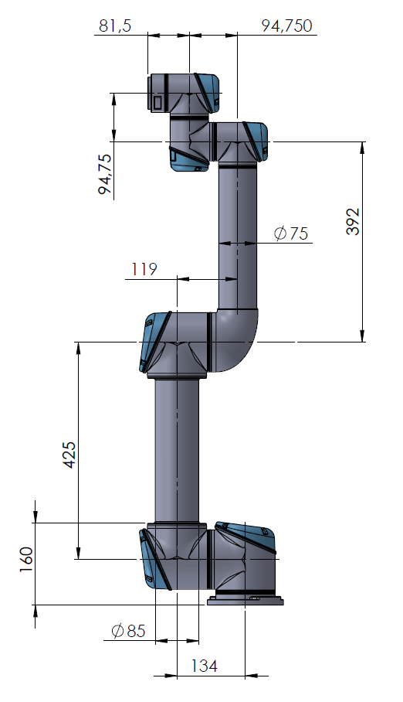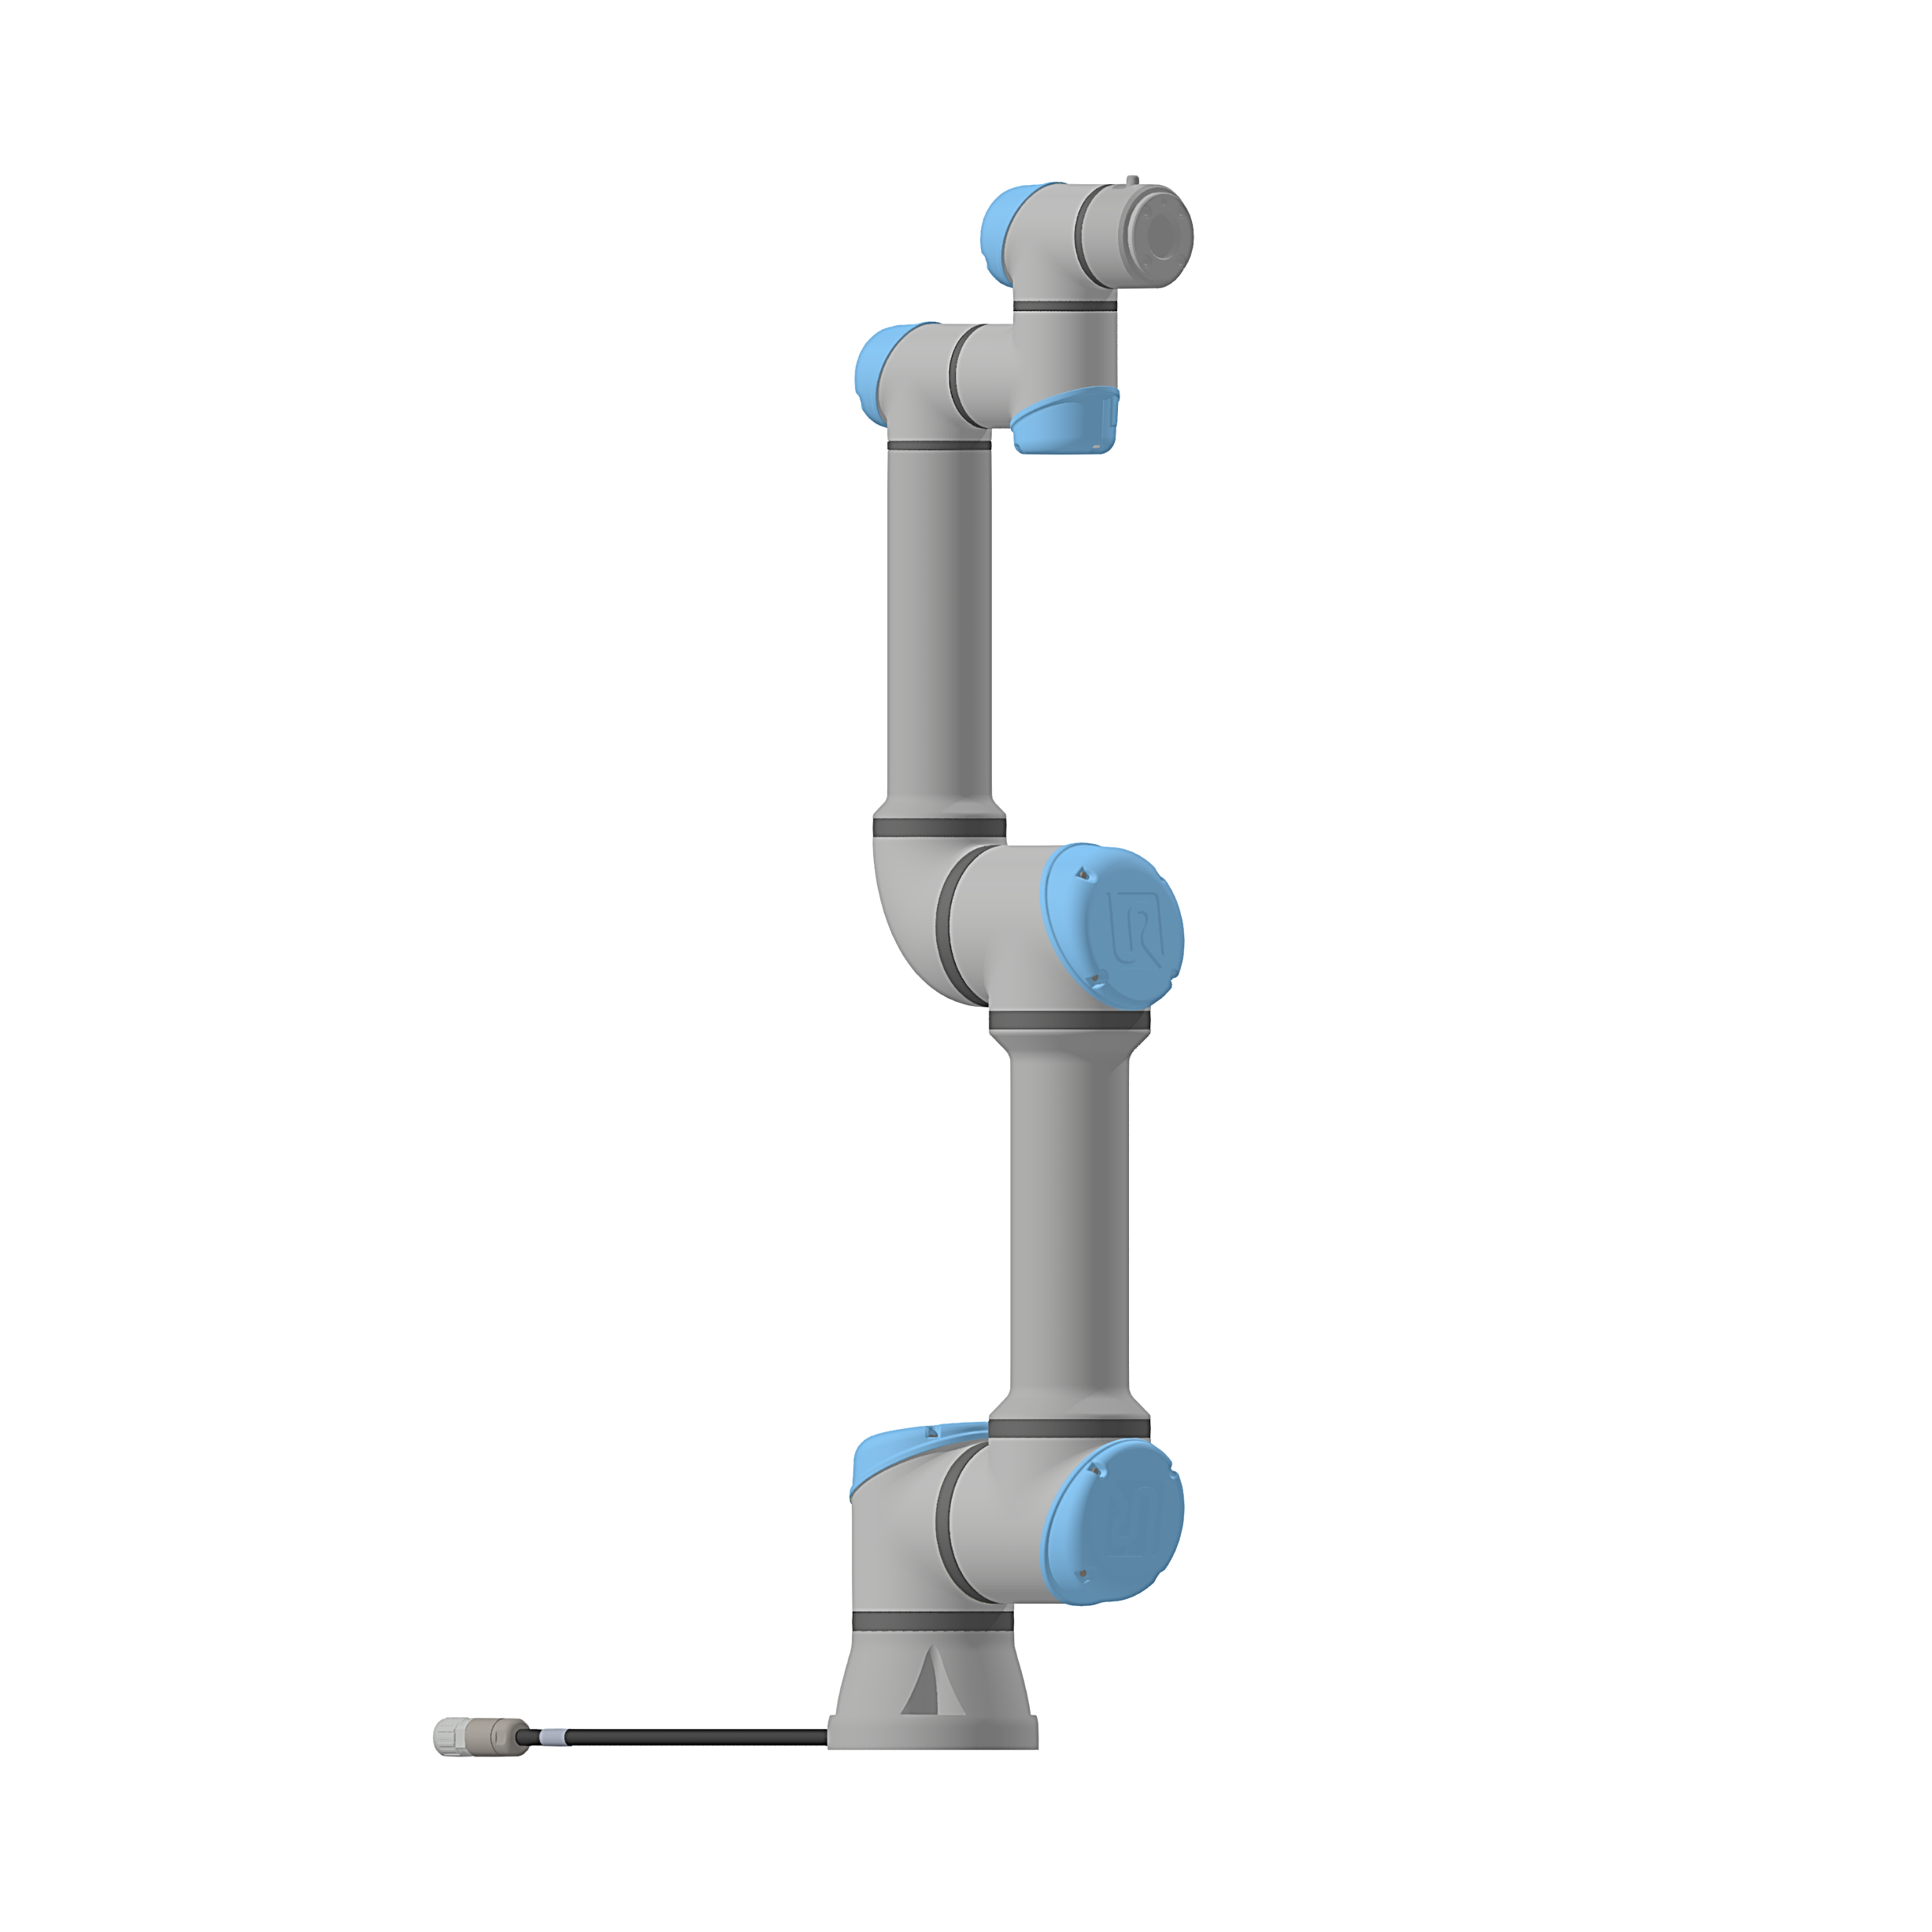

**{4}**

**4**

**X4**

**Z4**

**Y4**

**5**

**3**

**Y3**

**Z3**

**X3**

**{3}**

**2**

**1**

**Y2**

**Z2**

**X2**

**X1**

**Y1**

**Z1**

**{2}**

**{1}**

**X0**

**Y0**

**Z0**

**{0}**

***n***

***o***

***a***

**3**

**2**

**1**

**5**

**4**